FreeETarget

Service Manual
Version 6.2.1

When using freeTarget:

- Wear eye protection
- Maintain a safe distance
- Do not shoot into any areas except the open target areas.

The freeETarget project or contributors will not be responsible for any injuries when using this target of it’s components.

Target shooting can be dangerous so apply caution in everything you do.

SUMMARY 4
Glossary 4
INTRODUCTION 5
PC Client 6
Target 7
Control Circuit 8
USB or WIFI? 9
COMMISSIONING 11
Gathering the tools 11
Install the target 11
INstall the pc client 12
Setup the PC Client 12
FIRST SHOT 13
ADVANCED OPERATION 14
LED INDICATORS 15
LED Indicators, Normal Operation 15
LED Indicators, Fault Operation 15
MULTIFUNCTION SWITCHES 16
Connector assignment 16
Digital Inputs A/B (1/2) 17
Digital Input Operation 17
Digital Inputs or Outputs C/D 18
Input or Output Operation 18
FACTORY RESET 18
WiFi OPERATION 19
ACCESS Point 19
Station Mode 20
WiFi RESETTING THE TARGET 21
SETTINGS 23
CONTROL SETTINGS 24
INFORMATION ONLY 26
TYPICAL SETTINGS 26
DC Motor Witness Paper 26
Stepper Motor Witness Paper 27
Sensor Placement 27
WiFI Station 28
WiFi Access Point Mode 28
TOKEN RING 29
DOWNLOADING FIRMWARE 31
PREPARATION 31
Download Python 31
Install ESPTOOLS 31
DOWNLOAD 32
TROUBLE SHOOTING 36
ASSEMBLY TROUBLE SHOOTING 36
WiFi TESTING 37
OPERATIONAL TROUBLE SHOOTING 38
MISPLACED or NO SHOTS 38
WITNESS PAPER DOES NOT MOVE 39
USING TEAMVIEWER 39

SUMMARY
This document is the service manual for FreeETarget Version 5. It contains information about the operation for both the target and PC client. For details about the construction of individual components, please see the component documentation.
The document is organized in chapters:
Commissioning | Putting your target in service for the first time
LED Indicators | What to the LEDs mean
Multifunction Switches | Configuring the switches for your needs
WiFi Operation | Setting up the WiFi for your environment
Settings | How to configure the target to your applications
Uploading Firmware | How to put new software into the target
Trouble Shooting | Steps to take to resolve errors
It is suggested that you skim over all of the chapters to get an idea of what FreeETarget is capable of and what are the main elements of the system. Once that is done, start at the introduction and work up to commissioning.
At the end of commissioning, you should be able to shoot into the target and observe the results on the PC display.
If that fails, look into the trouble shooting chapter to make sure that there is no obvious fault that can be quickly fixed.
If all else fails, TeamViewer can be used to remotely log in and observe what is going on.

Glossary

Term | Description
Circuit | The signal processor to read the sensors and compute the shot location
PC Client | The program the user needs to see their score
Sensor | Microphone assembly to detect paper tearing when the projectile hits the target
Target | The assembly consisting of the circuit, housing, and target holder
TeamViewer | Web based client software that allows remote diagnostics

INTRODUCTION
FreeETarget is an open source project to make a low cost electronic target that can be used for training and reginal competitions.
The features that FreeETarget provides are:
- Low cost of entry
- Uses a standard Windows PC or laptop
- Precise representation of the score
- Ability to upgrade the software in the field
- Operation with WiFi or USB cables
A FreeETarget installation consists of three major elements:
- Target – - The thing that detects the shot
- Network - The means to transmit the shot information
- Client - The display device
The typical setups are shown in Figure 1:
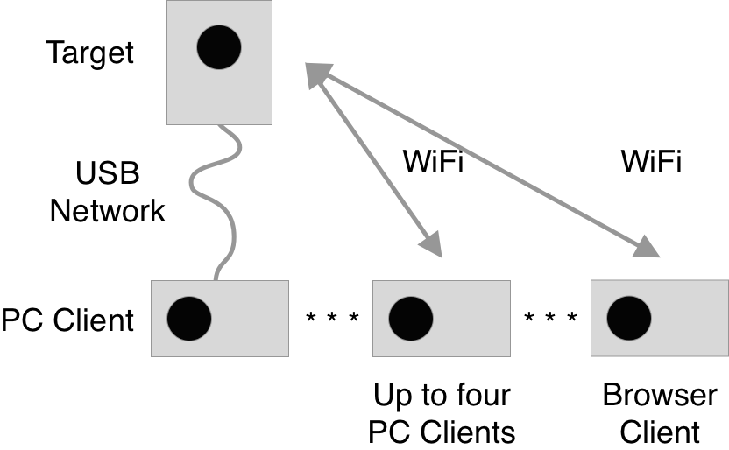
Figure 1: Installation Methods
The simplest method is to connect the target to the PC client using a 15 meter USB cable. These are readily available on Amazon or the local computer store. The USB connection allows for a direct connection between the two and is resistant to interference.
A more complex installation is to connect the target to the PC client over a WiFi connection. In this case, up to four PC Clients can be connected to the target:
- Shooting display
- Coach
- Parent
- Visitor
Details on the setup of each of these networks is discusses later.
Version 6.1.13 and higher software supports a web browser client to be attached to the PC so that the target can be monitored using a tablet or other browser device.

PC Client
Instead of a dedicated display module, FreeETarget uses a standard Windows PC or laptop. The computational burden is very low, so any PC with Windows 10 or 11 should work fine.
The software is available from the website free-e-target.com. Look for Technical Support and then downloads.
Once installed, launch the PC client and the display will look like the image shown in Figure 2.
The PC client allows the user to
- Connect to the target to begin a session
- Adjust the image to match the target (calibration)
- Load new firmware into the target
- Look at the inside of the target and debug it’s operation
- Setup the operating modes (ex WiFi network)
- Select an event to shoot
- Verify the software version of the PC client.
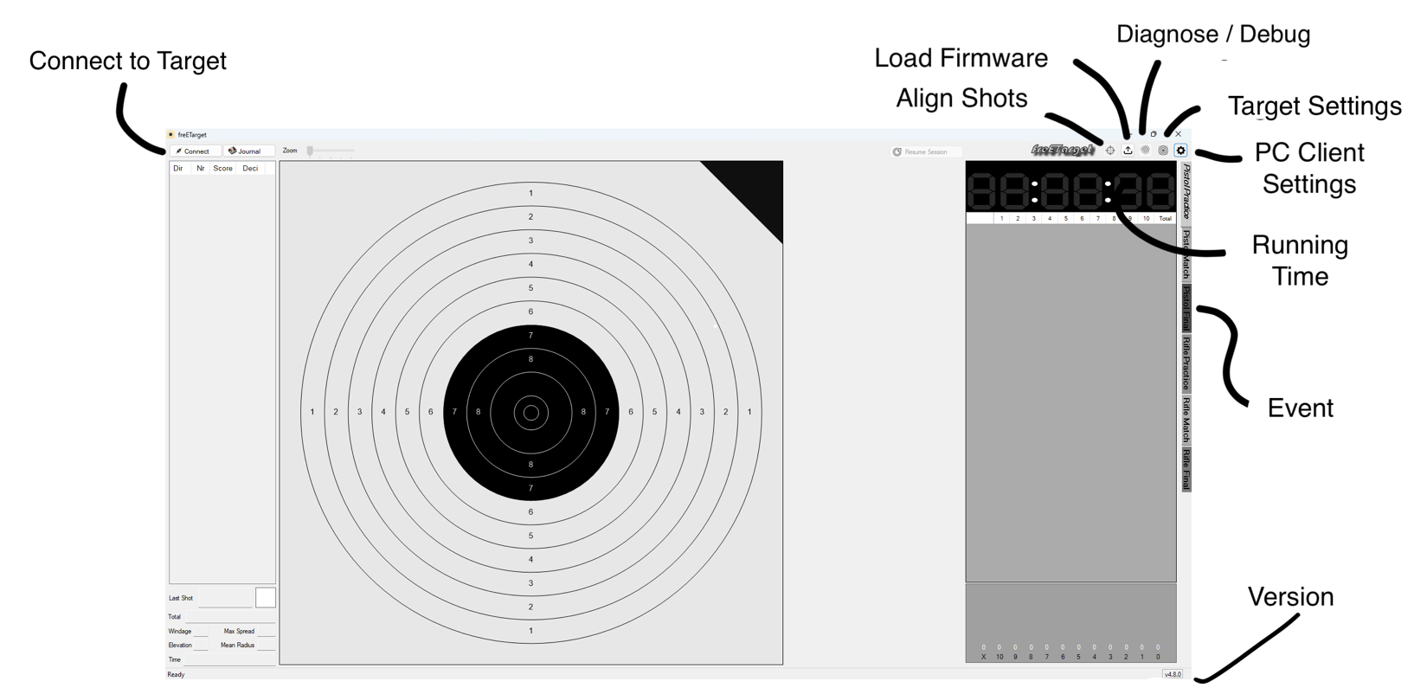
Figure 2: PC Client Menu Items

Target
The target is the device that detects the shot location and transmits the score to the PC Client for display.
The target ‘listens’ for the sound of the pellet breaking the paper. The sound radiates out from the hole and reaches four sensors located in the corner of the target. Based on the time delay between when the sensors detect the sound the algorithm computes a shot location.
Since the circuit detects the paper breaking, the sensors cannot detect a shot that penetrates an existing hole. For this reason, if you consistently shoot into the same hole, witness paper is required to present a fresh target for each shot.
Targets can be built from scratch with a circuit and some carpentry, Alternately, the target can be made up from a kit. Regardless of the method used to build the target, all targets contain the elements shown in Figure 3.

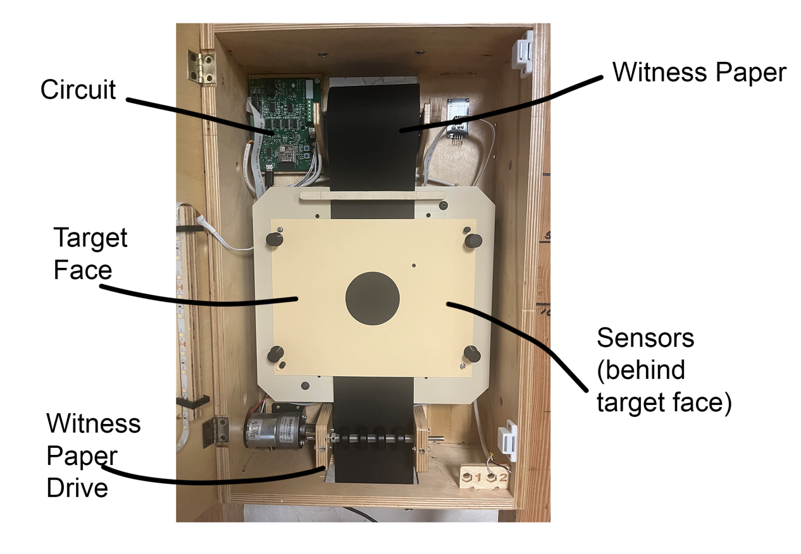
Figure 3: Typical Target Assembly

Control Circuit
The control circuit brings together all the electrical components needed to detect the shot. In addition, the circuit provides a user interface to control the operation of the target. The circuit is shown in Figure 4.
The firmware is located in an ESP32 that setup the hardware and eventually transmits the results. The incoming sound from the sensors is conditioned to detect the leading edge of the sound and start timers inside of the processor. Version 5 boards detect the sound at two points and use the time delay between the detections to work ou the slope of the sound and hence accurately time the shot.
Additionally, the circuit board has two switches to control the target without requiring a PC, and the status LEDs are used to display the running state and provides simple diagnostics information.
Temperature and humidity sensors adjust the algorithm to compensate for changes in the speed of sound based on the environment.

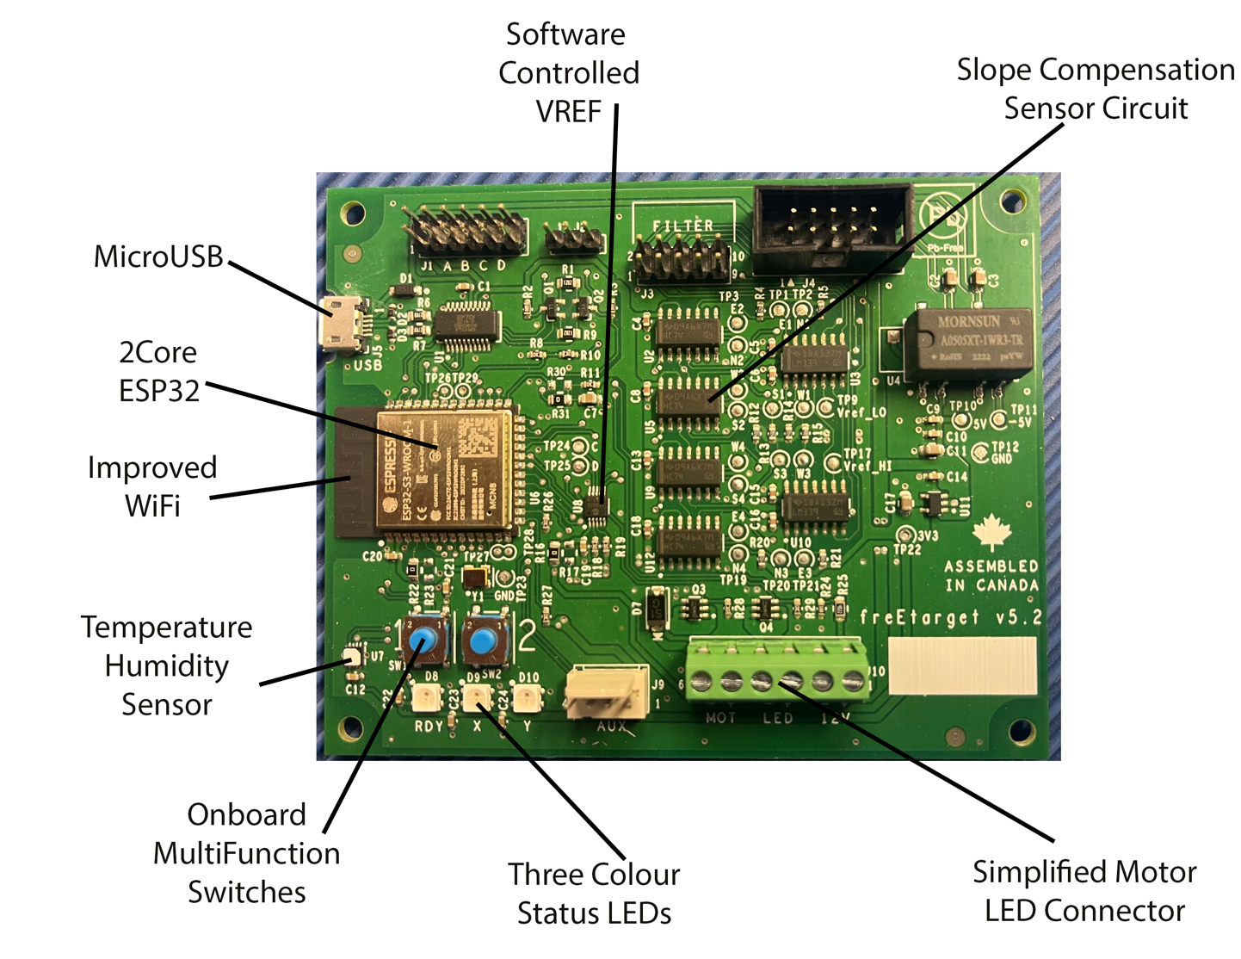
Figure 5: Circuit Annotation

USB or WIFI?
All Version 5 boards support WiFi and USB operation. For all practical purposes both USB and WiFi will provide the same target information. The differences are in the details of the connection media. The USB and WiFi are summarized
USB Operation
Needs a purpose. Built 15 meter cable. DO NOT try to attach eight two-meter cables together
Some PCs do not supply enough current to drive the cable and the board. You may need to add a power adapter near the target
USB is needed to reflash the software
Power on diagnostics only operate on the USB connection
WiFi Operation
Operates in both Access Point (easy) or Station Mode (allows internet access)
Software flashing cannot be done over WIFi
Supports up to four connections to each target
Supports a single HTTP client for web server access

It is recommended that the first target installation uses the USB connection, and subsequent ones can be a combination of USB and WiFi.

COMMISSIONING
Like any complex piece of technology, FreeETarget can be intimidating if not familiar with it’s operation. Commissioning is the sequence of steps that put the system into operation.
The steps to get an operating FreeETarget are
- Gather the tools to complete the installation
- Install the target
- Install the PC Client
- First shots
- Advanced operation

Gathering the tools
The following are required to begin installing a target system
- freETarget PC Client 4.5 or higher
- Firmware V5.2 or higher
- Target assembly
Network Minimum
- 2 meter USB cable
- 110 or 220 VAC outlet
Preferred
- 15 meter USB cable
- 110 or 220 VAC outlet
- WiFi network

Install the target
After you have assembled the freETarget into the target holder, inspect the following
- The flat cable is pressed firmly into the sensors and signal board
- There are no kinks or sharp bends in the flat cable.
- All of the sensors are correctly installed North through West
- When using the LED illumination
  - Verify the 12V supply wires are attached to the board
  - Verify that the LED wires are attached to the board
- When using the DC Motor witness paper drive
  - Verify that the 12V supply wires are attached to the board
  - Verify that the motor wires are correctly attached to the board

- When using the Stepper Motor witness paper drive
  - Verify that the stepper motor driver circuit is attached to the multifunction switch connector

- With the USB cable plugged into the PC, turn on the PC
  - Verify that the RDY LED is blinking green (or Blue)
  - Verify that no other LEDs are blinking

INstall the pc client
Visit the free-e-target.com -> Technical Support > Downloads to obtain the latest PC Client Software
Open the downloaded file from the download folder and install the software

Setup the PC Client
Launch the PC client and select Application Configuration from the upper right icons (Settings)
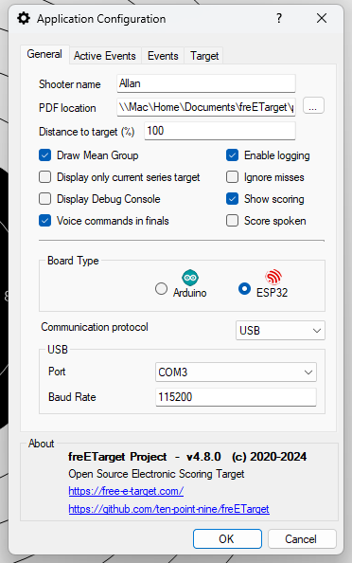
Figure X: Application Configuration

- Enter the information needed,
- Select ESP32 for Version 5 hardware
- Choose the USB port (for the initial setup)

FIRST SHOT
Set the target up ten meters from the firing point. Press the CONNECT button on the upper right of the PC client.
- Verify that after a few seconds the PC connects to the target
- The running timer increments or decrements.
- The target colour changes

If the target does not connect then review the connections and settings. Common mistakes include
- USB not configured correctly
  - Check the settings
- USB cable not plugged in correctly
  - Check the USB cables
- Defective USB cable
  - Repeat the setup but use a shorter (less than 2 meters) USB cable
Once the target connects, fire five shots into the paper. Try to separate the shots into 10, 8, 6, 4, 2 rings.
- Did the shots register in the correct place?
  - Yes, you’re done
  - No.
    - Did five shots register anywhere – Yes circuit works.
    - No shots registered – Recheck cables and connections
    - Press the DEBUG button (upper right)
      - Does it show an error?
- Do all 10 shots show up on the display?
  - No, check the cables and settings
- Are the shots correct, but the mirror image?
  - The sensors are installed correctly, but mirror image.
  - Swap North and East
  - Swap West and South
  - Go back to the beginning and test the circuit.
- Are the shots correct, but the reversed top and bottom?
  - The sensors are installed correctly, but upside down.
  - Swap North and West
  - Swap South and East
  - Go back to the beginning and test the circuit.

ALIGNING THE TARGET
Electronic targets are typically not aligned since the shooter adjusts their sights based on the computer display and not the paper. However, the target can be adjusted to accommodate alignment errors between the sensors and the paper
- Connect to the target with the PC client
- Using a paper target, take five shots into the paper
- Remove the paper and place it next to the target on the PC
- Open the Target Calibration box 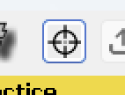
- 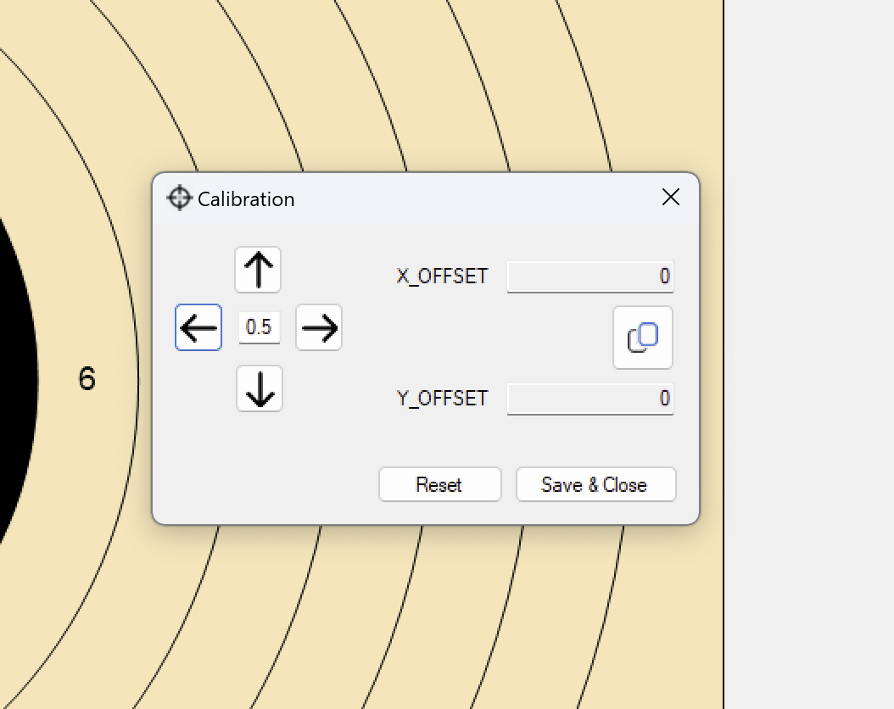
- Press RESET to clear any previous settings
- Use the arrows to adjust the image to match the paper target
Version 6.1.0 and Before
- Press Save & Close
  - This saves the aligment values into the PC
  - Each PC using the target will need to be aligned to the target

Version 6.1.1 and After
- Press the copy icon (two squares)
- Press X to close the dialog box. DO NOT SAVE & CLOSE
- Open the Debug dialog box 
- Paste (Control-V) into the Generic Command Box
- 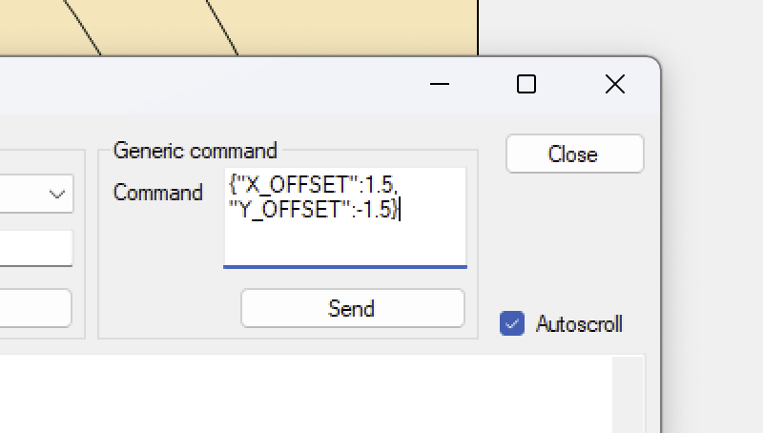
- Press SEND
  - This copies the alignment settings into the target
  - PCs using the target do not need to be aligned for each target
Trouble Shooting
If the procedure is not done in the correct order, or the alignments are saved twice, then the alignments will be added together and result in a worst alignment than before. If this happens.
- Open the Debug terminal
- Manually reset the aligment by setting X_OFFSET and Y_OFFSET to zero
- 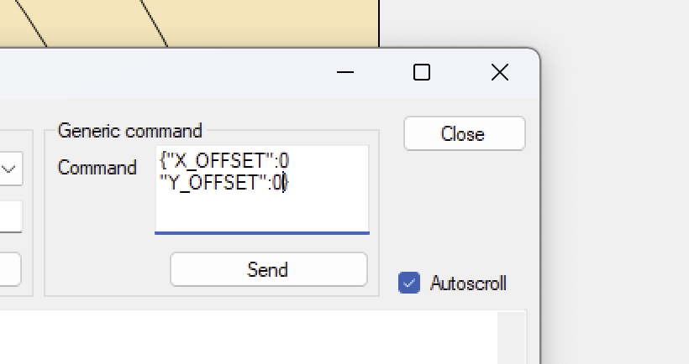
- Follow the instructions above and make sure to RESET the calibration before starting

ADVANCED OPERATION
Once you have the target correctly registering shots, it is time to move onto other features:
- WiFi Operation
  - Access Point – Simple operation
  - Station – Connect to your home network
  - Allow multiple people to watch your shooting
- Tabata Training
  - Select the ON and OFF time
  - Select how long between shots
- Rapid Fire shooting
  - Select the competition type
Refer to the relevant chapters here or the supplemental documentation contained on the web site

LED INDICATORS
The LED indicators are used to show the internal operation of the target, and fault diagnostics.

LED Indicators, Normal Operation
RDY | X | Y
RED | WHITE | BLUE | Power on self test (Hello World) to show that the software has booted and the circuit has some functionality
GREEN |  |  | The software has started but not ready for a shot
BLINK  GREEN |  |  | The software has completed startup and ready to receive shots
BLUE |  |  | The target has gone to sleep
 | BLINK  GREEN |  | The WiFi is in station mode but not connected to a PC
 | GREEN |  | The WiFi is in station mode and connected to a PC
 | BLUE |  | The WiFi I in access mode but not connected to a PC
 | BLINK  BLUE |  | The WiFI is in station mode and connected to a PC
 |  | RED | Insufficient voltage on the motor/LED 12V supply
 |  | YELLOW | Voltage present on the motor connector, but not enough to drive the motor.
 |  | BLINK  GREEN | Voltage sufficient for motor drive
 |  | BLUE | Witness Paper disabled by setting PAPER_TIME = 0

LED Indicators, Fault Operation
RDY | X | Y
RED | RED | RED | Failure detected on NORTH sensor
RED | RED | GREEN | Failure detected on EASH sensor
RED | RED | BLUE | Failure detected on SOUTH sensor
RED | RED | YELLOW | Failure detected on WEST sensor
RED | GREEN | RED | Miss detected

MULTIFUNCTION SWITCHES
The Multi Function Switches are general purpose inputs and outputs that can be set to perform a user defined operation.
The multifunction connector is located on the upper left side of the circuit board. It provides four signals A, B, C, and D along with ground references and a voltage supply. The intention is that additional switches or LEDs can be added to the target and the operation determined by software configuration.
The connector is illustrated in Figure 5.
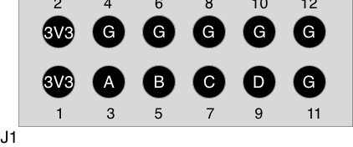
Figure 5: Multifunction Connector
In addition, two switches on the circuit board marked 1 and 2 are connected directly to inputs A and B on the multifunction connector.This allows the user to manage the target without additional hardware

Connector assignment
The 12 pins are assigned
1, 2 | 3.3 Volt , 50mA supply for interfaces
4, 6, 8,10, 11, 12 | Digital Ground
3 | Digital input A, also connected to push button 1
5 | Digital input B, also connected to push button 2
7 | Digital input or output C, defined in software
9 | Digital input or output C, defined in software

Digital Inputs A/B (1/2)
Push button switches 1 and 2 are routed to discrete inputs A & B and have five modes of operation
- Tap switch 1
- Tap switch 2
- Hold switch 1
- Hold switch 2
- Hold switches 1 and 2 together
When pressed, the software starts a timer, if the switch is released inside of 2 seconds, it is considered a tap. If the switch is held for more than 1 second, it is a hold. If both are held at the end of 1 second, then BOTH switches are held

Digital Input Operation
The switches are configured by using the JSON command to each of the switches and modes, Instructions for using the JSON commands are found in the section SETTINGS found in this document.
- {“MFS_HOLD_1”:X}
- {“MFS_HOLD_2”:X}
- {“MFS_HOLD_12”:X}
- {“MFS_TAP_1”:X}
- {“MFS_TAP_2”:X}
Where the value of X is defined in Table A
Table A: Digital Input MFS Values
Value | Action | Description
0 | Power Tap. | Wake the target up if it has gone to sleep
1 | Paper Feed | Turn on the witness paper drive to feed paper
2 | LED Adjust | Increase the brightness of the LEDs until 100% and then reset to zero
3 | Paper Shot | Advance the paper a set distance as if a shot has been recognized
4 | PC Test | Simulate a random shot sent to the PC client
5 | On / Off | Put the target to sleep
6
7
8

Digital Inputs or Outputs C/D
Connections C and D can be programmed as input or outputs depending on the

Input or Output Operation
The switches / outputs are configured by using the JSON commands
- {“MFS_HOLD_C”:X}
- {“MFS”HOLD:D”:X}
- {“MFS_SELECT_CD”:X}
Where the value of X is defined in Table B
Table B: Digital I/O MFS Values
Value | Action | Description
9 | No action
10 | Target Type | Used to inform the PC of a specific target type
18 | Rapid RED | Output is used to drive the RED indicator when in rapid fire
20 | Rapid GREEN | Output is used to drive the GREEN indicator when in rapid fire
22 | Rapid LOW | Set the rapid indicator LED to be active low (0 turn on LED)
24 | Rapid HIGH | Set the rapid indicator LED to be active high (01turn on LED)
26 | Stepper Drive | The output is used to drive a stepper motor

FACTORY RESET
Holding the 1 and 2 buttons closed and applying power until the RDY light flashes will reset the board back to the factory defaults.

WiFi OPERATION
The Version 5 hardware has two modes of WiFI operation
- Access Point. The target provides its’ own SSID, typically FET-TARGET. Each target is a unique SSID
- Station. The target uses the local (home) SSID. Multiple targets can be on the same SSID

The default operation of the FreeETarget is to be an access point, This allows for simple setup, but means that the Client PC cannot be on the internet at the same time as the target is connected.
While harder to setup, Station mode allows multiple targets to be on the same network as the PC and an internet connection

ACCESS Point
Access point is the default operation. Access point sets the SSID of the target to be FET-name, where name can be changed through a command line
The controls for the access point are:
Control | Description
{“NAME_ID”:x} | The NAME_ID allows the operator to select an SSID from a list of available SSIDs  0 – FET-TARGET. (Default)  1 – FET-1  2 – FET-2  3 – FET-3  4 – FET-4  5 – FET-5  6 – FET-6  7 – FET-7  8 – FET-8  9 – FET-9  10 – FET-10  11 – DOC  12 – DOPEY  13 – HAPPEY  14 – GRUPMY  15- BASHFUL  16 – SNEEZY  17 - SLEEPY  18 – RUDOLF  19 – DONNER  20 – BLITZEN  21 – DASHER  22 – PRANCER  23 – VIXEN  24 – COMET  25 – CUPID  26 - DUNDER  27 – ODIN  28 – WODEN  29 – THOR  30 – BALDAR  99 – User Defined (FET-userdefined)  100 – User Defined (userdefined)  101 – Serial number (FET-<SERIAL_NUMBER”)
{“WIFI_CHANNEL”:X} | Sets the WiFi channel  Use this control if there is a conflict with another network near the target  Range 1-11, Default 6. U
{“WIFI_HIDDEN”:X} | Hides the SSID from the network  0 – Visible  1 - Hidden
{“WIFI_PWD”:”xxxx} | Assigns a password to the target SSID

IMPORTANT
When used in Access Mode, the target sets itself to a fixed IP address of 192.168.10.9 and port 1090
The SSID used by the PC must match the one assigned by NAME_ID, and is typically FET-TARGET

Station Mode
Station mode allows the target to be on the same network as other devices in the building. For example, the target can be on the home network allowing the target and teamViewer to be active at the same time on the same network
The controls for the Station Mode are:
Control | Description
{“WIFI_PWD”:”xxxx”} | Assigns a password to the active SSID
{“WIFI_SSID”:”xxxx”} | Selects the SSID to be used by the target
 | Under normal operation the target will receive a dynamic IP address from the router. To fix the IP address between operation, it is necessary to use a static IP
{“WIFI_IP”:”xxxx”} | Forces a static IP into the target
{“WIFI_GATEWAY”:”xxxx”} | Assigns a gateway address to the target

IMPORTANT
When used in Station Mode, the router assigns the IP address to the target. To find the IP address that has been assigned to the target, use the {“ECHO”:0} command to list the settings and look for
The IP address can be overwritten by using the {“WIFI_IP”:”xxxx”} command
WIFI_IP_ADDRESS: A.B.C.D, where A.B.C.D is the address that needs to be entered into PC client configuration
When using Station Mode, the PC Client will issue a warning that the SSID is not of the form FET-name. This is for information only and can be ignored.

TARGET NAME ACCESS
Starting in Version 6.1.12, the target can be accessed using it’s target name.
Using {“ECHO”:0}, to find the target name, for example FET-TARGET.
The target can be using <TARGET-NAME>.local in place of the older IP address (192.168.86.200)

WiFi RESETTING THE TARGET
While shooting, the target keeps track of the last 100 (40 sighters, 60 on score) shots. When the PC Client connects over WiFi, the scores from the beginning of the session are downloaded at once. This is done so that (say) a coach can log into their student’s target and see all of the shots since the beginning.
In operation, connecting over USB will automatically reset the target back to the beginning. Connecting by WiFi does not have this feature since resetting every time that someone connects on WiFi would be confusing. To get around this problem, the target has the setting
{“WIFI_RESET”:X}.
The default is 0, so that the target is not reset. Setting X to 1 will reset the target whenever the FIRST user logs in over WiFI.
The ideal operation is for the firing point to be connected by USB and the target is reset every time the firing point connects. If no USB is used, then {“WIFI_RESET”:1} should be used so that the shooter resets the target on the first connection.

BROWSER OPERATION
Version 6.1.11 and higher supports WiFi operation using a browser. Browser operation is intended to be used as a convenience in place of the PC Client.
The browser based FreeETarget interface is in two parts:
1 – The main target page showing your shots, and;
2 – A control page to manage the target remotely.

You will need to know the name or IP address of your target.

To start the target, enter the target URL
<target_name>.local
This starts the target and records your shots. The target will automatically disconnect after 15 minutes of inactivity.

To control the target, access the menu port
<target_name>.local:8080
This will present the menu buttons:
START – Clear any shots and start recording
STOP – Stop recording shots and return to the HELP page

To find out information about your target, use the WHO command
<target-name>.local/who
Or
<target-name>.local:8080/who

SETTINGS
The software has a number of settings that affect the operation of the unit
Settings on the target are changed using the debug tab on the PC client.
- Connect to the target as if you were shooting a match
- Select the Debug icon on the upper right (looks like a finger print). If it is not visible, make sure that ESP32 is selected in the setup.
- The debug menu will appear as shown in Figure
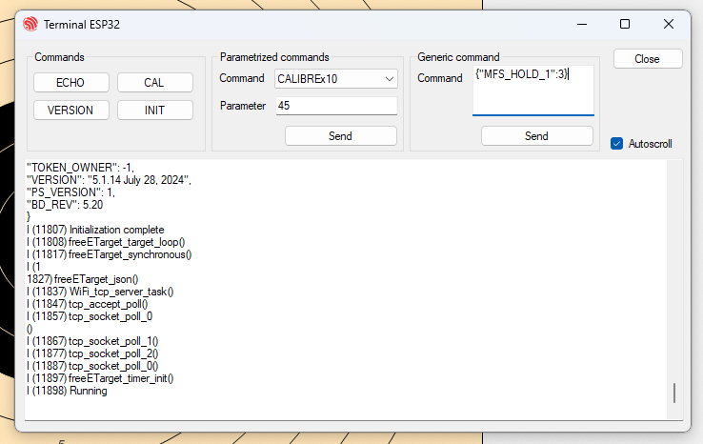
Figure Z: Debug Dialog Box
- Enter the setting in the Generic Command box and press [SEND] to setting to the target.
- Results from the target appear in the large dialog box

CONTROL SETTINGS
The settings that are available are shown in Table S. To change a settings, use the text in the Setting column and form the JSON command
{“setting”:value}
For example {“FOLLOW_THROUGH”:4} or {“SENSOR_DIA”:232.5}
Hidden settings are not displayed using an ECHO command, but can be set using the standard method, ex {“TABATA_ON”:1}
Table S: FreeETarget Settings
Setting | Hidden | Description | Typical Value | Saved
ANGLE |  | Orientation of the sensors from vertical | 45 degrees | Y
AUX_MODE |  | Enables the AUX port for operation | 0 – AUX port disabled | Y
FACE_STRIKE | Y | Enables face strike detection | Must be zero | Y
FOLLOW_THROUGH |  | Time to wait before transmitting score | 0 – Immediate, 5 - Training | Y
KEEP_ALIVE |  | WiFI beacon used to keep the WiFi connection alive | 120 | Y
LED_BRIGHT |  | LED brightness 0-100% | 0 – Off, 100 - fully on | Y
MFS_TAP_2 |  | Action to perform if switch 2 is tapped | 0 – Wake up | Y
MFS_TAP_1 |  | Action to perform if switch 1 is tapped | 3 – Paper shot | Y
MFS_HOLD_2 |  | Action to perform when switch 2 is held for 2 seconds | 5 – Turn the target off | Y
MFS_HOLD_1 |  | Action to perform when switch 1 is held for 1 second | 1 – Paper feed | Y
MFS_HOLD_12 |  | Action to perform if both MFS switches are held down | 2 – LED adjust | Y
MFS_HOLD_C |  | Action to perform with GPIO C | 9 – No action | Y
MFS_HOLD_D |  | Action to perform with GPIO D | 9 – No acton | Y
MFS_SELECT_CD |  | Output polarity of signals C and D | 22 – Invert output | Y
MIN_RING_TIME |  | Time before next shot is recognized after the current shott | 500 ms | Y
NAME_ID |  | Index to select a target name for FET- | 0-31, 99 & 100default 0 | Y
NAME_TEXT |  | Text target name used when NAME_ID is 99 or 100 |  | Y
OTA_URL |  | URL where OTA binary is stored | Do not change | Y
PAPER_ECO |  | Distance in mm to ignore shot and not move paper | 0 – Disabled,  1 to 100 mm | Y
PAPER_SHOT |  | How many shots to fire before advancing paper | 0 – Advance every time | Y
PAPER_TIME |  | Sets the time the motor turns to advance the witness paper | 500ms | Y
PCNT_LATENCY": |  | Uses a calibrated offset to improve the detection accuracy | 0 – Disabled, 32 Typical | Y
POWER_SAVE |  | Idle time in minutes before going to sleep | 0 – Off, Typical 30 minutes | Y
RAPID_COUNT | Y | How many shots in a rapid fire string |  | N
RAPID_ENABLE | Y | Enable rapid fire mode | 1 - Enable | N
RAPID_TIME | Y | How long will the rapid fire event last in seconds |  | N
RAPID_WAIT | Y | How long to delay after rapid fire has been enabled |  | N
REMOTE_ACTIVE |  | Is there a remote server that can receive scores | 1 – Enable | Y
REMOTE_KEY |  | Access key for authentication | Text String | Y
REMOTE_URL |  | URL of the remote server | IP Address (ex “192.168.1.1”) | Y
SEND_MISS |  | Send a record to the PC whenever a shot has been missed | 0 – Miss not sent | Y
SENSOR_DIA |  | Calibrated distance between sensor faces | 232mm for air pistol or air rifle | Y
STEP_COUNT |  | How many steps to issue stepper motor witness paper | 0 – Disabled | Y
STEP_RAMP |  | How many cycles to change during ramp-up | 0 – Disabled | Y
STEP_START |  | Number of cycles to start stepping at | 0 – Disabled | Y
STEP_TIME |  | Time interval in ms between steps | 0 – Disabled | Y
TABATA_ENABLE | Y | Enable the Tabata training mode | 0 – Disabled | N
TABATA_ON | Y | Time in seconds that the LEDs are on during a Tabata cycle |  | N
TABATA_REST | Y | Time in seconds that the LEDs are off between shots |  | N
TABATA_WARN_OFF | Y | Time in seconds that the LEDs are off after the warning |  | N
TABATA_WARN_ON | Y | Time in seconds that the LEDs are on to warn the shooter |  | N
TARGET_TYPE |  | Target Override for alternate targets | 0 – No override  4 – 5 bull target 74mm  5 – 5 bull target 79mm  11 – 10bull + sighters (Orion)  12 – 10 bull + sighters (NRA) | Y
TOKEN |  | Enable Rapid Fire token ring | 0 – Disable,  1 Enable | Y
TRACE |  | Display diagnostics trace.  Cleared on next power cycle  DLT_CRITICAL – Error effects normal operation  DLT_INFO – Internal operational information  DLT_APPLICATION – Scoring calculations | 1-DLT_CRITICAL  2-DLT_INFO  4-DLT_APPLICATION  8-DLT_COMMUNICATION  16-DLT_DIAG  32-DLT_DEBUG  64-DLT_SCORE  128-DLT_HTTP  256 – DLT_HEARTBEAT | N
VREF_LO |  | Shot detection low voltage threshold | 1.25 Volts | Y
VREF_HI |  | Shot detection high voltage threshold (VREF_HI > VREF_LO) | 2.0 Volts V5 hardware only | Y
WIFI_CHANNEL |  | WiFi channel used with Access Point targets | 1 – First  6 – Recommended  11 - Last | Y
WIFI_GATEWAY |  | Location of the gateway to rthe remote server | Text (ex “192.168.1.0”) | Y
WIFI_HIDDEN |  | Hide the SSID of an access point target (FET-xxx_ | 0 Visible SSID  1 – Hode SSID | Y
WIFI_IP |  | Static IP of the target (empty => not used) | Text (ex “192.168.1.54”) | Y
WIFI_PWD |  | WiFi password associated with SSID. Both Access point and Station Modes | Default is empty, no password | Y
WIFI_RESET_FIRST |  | Reset the target when the FIRST WiFi connection is made | 0 – Do not reset  1 – Reset on first connection | Y
WIFI_SSID |  | SSID associated with Station Mode targets | Default is empty, Access Mode  Non empty, Station Mode | Y
X_OFFSET |  | Offset applied to X axis to calibrate score | 0 – Disabled until calibrated | Y
Y_OFFSET |  | Offset applied to Y axis to calibrate score | 0 – Disabled until calibrated | Y
Z_OFFSET |  | Vertical distance from target plane to sensor plane | 13mm typical | Y
NORTH_X/NORTH_Y | Y | Correction in mm from ideal location. + away from centre | 0 recommended | Y
EAST_X/EAST_Y | Y | Correction in mm from ideal location | 0 recommended | Y
SOUTH_X/SOUTH_Y | Y | Correction in mm from ideal location – closer to centre | 0 recommended | Y
WEST_X/WEST_Y | Y | Correction in mm from ideal location | 0 recommended | Y
LOCK |  | Enter a lock code to prevent changes to the configuration | 0 Unlocked | Y
UNLOCK |  | Entering the lock code will unlock the target configuration | Lock code | N

INFORMATION ONLY
The items shown in Table S provide insight into the operation but cannot be changed by the user
Command | Description | Typical Values
RUN_STATE | Internal running state | 1 – Startup  2 – In operation (normal)  4 – Test Mode  8 - Sleep
RUNNING_MINUTES | How long the target has been turned on
TIME_TO_SLEEP | How long before the target goes to sleep
TEMPERATURE | Temperature in C inside the target. Used to calculate speed of sound
RELATIVE_HUMIDITY | Humidity inside the target. Used to calculate speed of sound
TIMER_COUNT | Expected maximum time expected to occur after shot | 1 LSB – 100ns
V12 | LED / Witness paper drive voltage | Nominally 12V
WIFI_MAC | MAC address of the WiFI
WIFI_IP_ADDRESS | IP address used by target
WIFI_MODE | Access Point or Station mode programmed into target
TOKEN_RING | Assigned token ring address
TOKEN_OWNER | Which target is the master of the token ring | Should be 1
VERSION | Current firmware version
PS_VERSION | Persistent storage version. Used for automatic updates
BD_REV | Board revision

HIDDEN COMMANDS
The target has a number of commands that can be used control the target.
Command | Description | Typical Values
50M | Set the configuration for a 50 meter pistol target | 0
BYE | Turn off the target and reduce power | 0
ECHO | Display the internal settigns | 0
INIT | Reinitialize the board | 0
MFS? | Show the available MFS settings | 0
OTA | Start and OTA download from the command mode | 0
RESET | Reboot the target | 0
TEST | Run the onboard diagnostics | 0 –Test options

TYPICAL SETTINGS
The settings to implement typical actions are provided below.

DC Motor Witness Paper
The DC motor witness paper drive turns on the motor for a short period of time. Roughly speaking the paper will advance 40mm with a 500ms ON time. To change the amount of paper that advances, it is necessary to shorten or lengthen the time the motor runs.
Duration = 500 x Desired Movement / 40
To correctly set up the DC motor drive, use the following settings
{“PAPER_ON”:500}
{“STEPPER_COUNT”:0}
{“STEPPER_TIME”:0}
The setting {“PAPER_ECO”:X} is used to enable the witness paper drive if the hole is within X mm of centre.

Stepper Motor Witness Paper
The stepper motor requires a separate circuit, for example ROB-14450 available from DigiKey. This circuit converts pulses from the FreeETarget board into energizing the stepper motor windings.
To setup a stepper motor use the following settings:
{“PAPER_ON”:0
{“STEPPER_COUNT”:60}
{“STEPPER_RAMP”:10}
{“STEPPER_START”:100}
{“STEPPER_TIME”:20}
{“MFS_HOLD_C”:26}
{“MFS_HOLD_D”:28}
IMPORTANT
The settings will be strongly influenced by the stepper motor used on the target and settings may need to be adjusted in place
The STEPPER_COUNT=X determines how far the paper advances, and STEPPER_TIME= is the duration of each pulse to the stepper (typically in the order of 20ms)
MFS_HOLD_C = 26 converts MFS signal C into the stepper motor driver pulse
The setting {“PAPER_ECO”:X} is used to enable the witness paper drive if the hole is within X mm of centre.

Sensor Placement
The sensors are located a distance apart that corresponds to the size of the 1 ring. For a pistol target, this is 230mm. There may be an adjustment if the sensing circuit is behind the front surface of the microphone.
If the target is set up for 50m small.bore, or large bore rifles, the sensors will need to be relocated, to another distance.
{“SENSOR_DIA”:X}
Where X is the distance in mm across the target. X does not necessarily need to be a whole number, the value X=232.5 is a legal value.

WiFI Station
The WiFI station mode (the target is on the home network) is enabled by setting
{“WIFI_SSID”:”home network”} Example “myHome”
{“WIFI_PWD”:”home password”} Example “12345678”
Optional Static IP
{“WIFI_IP”:”IP address of the target ”} Example 192.168.1.54
{“WIFI_GATEWAY”:”IP address of the gateway ”} Typically 192.168.1.0

WiFi Access Point Mode
The WiFi accces point mode means that the target generates it’s own SSID, typically FET-TARGET. To enable acces point mode, it is necessary to turn off the station mode.
{“WIFI_SSID”:””}
{“WIFI_PWD”:”password”} The target has a password
{“WIFI_PWD”:””} The target does not have a password
{“WIFI_HIDDEN”:X} X = 0 the SSID is not hidden, X=1 hides the target
{“NAME_ID”:Y} Change the name of the target (see settings in WiFi Operation)

The Auxilary Connector is used as an alternative communications connector. This would be used to connect an RS-485 interface, tor connect multiple targets together using a Token Ring
The four pin AUX connector has the following connections
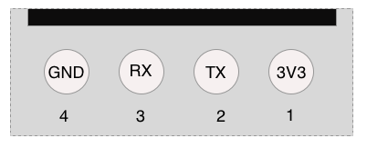
Figure Z: Auxiliary Connector
The connector provides 3.3 volts to drive an RS-232 or RD-485 convertor. Current is limited to about 50mA

TOKEN RING
The Auxiliary connector can be used as a token ring connector to join up to 7 targets and transmit the scores to the PC.
The connection for the token ring is shown in the figure below.
The transmit of 1 goes to the receiver of the next, and all the way round the ring. All of the ground connections are joined together. Be careful to ensure that there are no ground loops before attaching the token ring cable.
For the target that is connected to the PC Client, set {“TOKEN”:1}. The remainder are set to {“TOKEN”:2}
The token ring is disabled if any of the targets are set to {“TOKEN”:0}
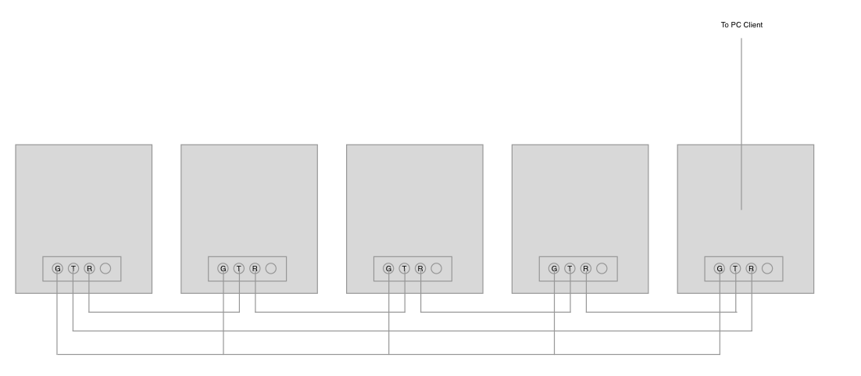
Figure Z: Token Ring Wiring

DOWNLOADING FIRMWARE
The target has the ability to be reprogrammed when new features are added or bugs fixed.
Downloading to the target performed in two steps
- Preparation – Setting up the PC Client download software, done once
- Upload – Uploading new software to the target

PREPARATION
Version 5 hardware uses an ESP32 microcontroller. The download software is provided by a Python module that must be installed before the firmware can be loaded. Once the Python module have been downloaded once, there is no need to do it again

Download Python
From your web browser, search fo PYTHON DOWNLOAD
Follow the link and select Download Python (Note the version number may be higher than shown here)
Download and install Python.
If prompted, select OVERRID MAX PATH LENGTH
Restart your computer to update the PATH variable

Install ESPTOOLS
Once the PC has finished restarting, launch a command prompt and run the command
pip install “esptool<5”l
The PC will return something that looks like
C:\Users\allan>pip install esptool
Requirement already satisfied: esptool in c:\users\allan\appdata\local\packages\pythonsoftwarefoundation.python.3.11_qbz5n2kfra8p0\localcache\local-packages\python311\site-packages (4.7.0)
Requirement already satisfied: bitstring>=3.1.6 in c:\users\allan\appdata\local\packages\pythonsoftwarefoundation.python.3.11_qbz5n2kfra8p0\localcache\local-packages\python311\site-packages (from esptool) (4.1.4)
Requirement already satisfied: cryptography>=2.1.4 in c:\users\allan\appdata\local\packages\pythonsoftwarefoundation.python.3.11_qbz5n2kfra8p0\localcache\local-packages\python311\site-packages (from esptool) (42.0.2)
Requirement already satisfied: ecdsa>=0.16.0 in c:\users\allan\appdata\local\packages\pythonsoftwarefoundation.python.3.11_qbz5n2kfra8p0\localcache\local-packages\python311\site-packages (from esptool) (0.18.0)
Requirement already satisfied: pyserial>=3.0 in c:\users\allan\appdata\local\packages\pythonsoftwarefoundation.python.3.11_qbz5n2kfra8p0\localcache\local-packages\python311\site-packages (from esptool) (3.5)
Requirement already satisfied: reedsolo<1.8,>=1.5.3 in c:\users\allan\appdata\local\packages\pythonsoftwarefoundation.python.3.11_qbz5n2kfra8p0\localcache\local-packages\python311\site-packages (from esptool) (1.7.0)
Requirement already satisfied: PyYAML>=5.1 in c:\users\allan\appdata\local\packages\pythonsoftwarefoundation.python.3.11_qbz5n2kfra8p0\localcache\local-packages\python311\site-packages (from esptool) (6.0.1)
Requirement already satisfied: intelhex in c:\users\allan\appdata\local\packages\pythonsoftwarefoundation.python.3.11_qbz5n2kfra8p0\localcache\local-packages\python311\site-packages (from esptool) (2.3.0)
Requirement already satisfied: bitarray<3.0.0,>=2.8.0 in c:\users\allan\appdata\local\packages\pythonsoftwarefoundation.python.3.11_qbz5n2kfra8p0\localcache\local-packages\python311\site-packages (from bitstring>=3.1.6->esptool) (2.9.2)
Requirement already satisfied: cffi>=1.12 in c:\users\allan\appdata\local\packages\pythonsoftwarefoundation.python.3.11_qbz5n2kfra8p0\localcache\local-packages\python311\site-packages (from cryptography>=2.1.4->esptool) (1.16.0)
Requirement already satisfied: six>=1.9.0 in c:\users\allan\appdata\local\packages\pythonsoftwarefoundation.python.3.11_qbz5n2kfra8p0\localcache\local-packages\python311\site-packages (from ecdsa>=0.16.0->esptool) (1.16.0)
Requirement already satisfied: pycparser in c:\users\allan\appdata\local\packages\pythonsoftwarefoundation.python.3.11_qbz5n2kfra8p0\localcache\local-packages\python311\site-packages (from cffi>=1.12->cryptography>=2.1.4->esptool) (2.21)

[notice] A new release of pip is available: 24.0 -> 24.1.2
[notice] To update, run: C:\Users\allan\AppData\Local\Microsoft\WindowsApps\PythonSoftwareFoundation.Python.3.11_qbz5n2kfra8p0\python.exe -m pip install --upgrade pip
Type
PATH
Verify that a line resembling
C:\Users\user_name\AppData\Local\Packages\PythonSoftwareFoundation.Python.3.11_qbz5n2kfra8p0\LocalCache\local-packages\Python311\Scripts;
Should appear in your path variable

DOWNLOAD
Once the basic download package has been installed, you can download new firmware whenever necessary
Visit the free-e-target.com -> tech support -> download for the current release software. Download and save the file (typically to your download folder)
In the PC client, from the upper right corner, select the download icon. The download menu will appear
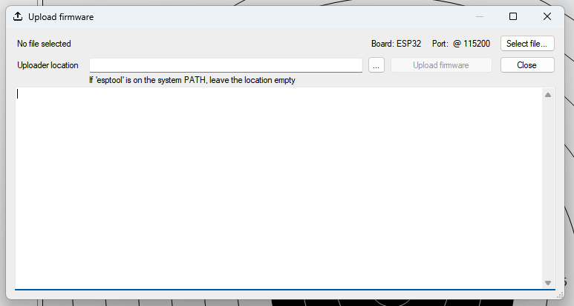
Select the download file, typically freetarget_version.bin
Press the download firmware button. If everything is properly installed the PC will connect to the target and begin the download.

Starting with Version 6.1.0 of the target firmware, software updates can be carried out simply by pressing a button on power up and letting the target update itself from a remote web site. This simplifies the operation of the target and makes maintenance much easier.
REQUIRED
- FreeETarget PC software version 4.10.2 or higher
- Target loaded with firmware version 6.1.0 or higher
- The target connected to the home network with internet access
OVER THE AIR UPDATE
Before beginning the update, make sure that the target is on the home network, and that network is connected to the internet. Targets using the FET-TARGET SSID will not be able to use this feature.
To update the software, carry out the following steps
- Power off the target
- Press and hold the #1 button. Do not release!
- Apply power to the target
- Wait until the RDY LED turns BLUE. This is the signal that the upload has begun
- You can let go of the #1 button
- The X LED will blink blue as the upload process continues
- The upload ends when the RDY LED stays BLUE, and the X and Y buttons change to RED or GREEN.
- Observe the colours of the X and Y LEDs
- Press the #1 button to end the process and start the target running

FINISHING
When the update is complete, the LEDs will tell you whether or not the upload was successful
RDY | X | Y | Description
BLUE | GREEN | GREEN | The update was successful and the target it ready to run
BLUE | RED | DARK | The target could not reach the internet.  Check your router and internet.  Verify that the target is on the home network and that the target connected to the router.
BLUE | DARK | RED | The update failed. Possible cause: internet failed
BLUE | RED | RED | The update failed and should not be repeated. This error occurs if there is a defect in the download file that needs to be connected at the server and not the target.

ROLLBACK RECOVERY
If something goes wrong with the new software, you can fall back to the previous version by
- Remove power from the target
- Press and hold the #1 button. Do not release!
- Apply power to the target
- Wait until the RDY LED turns BLUE. This is the rollback has completed

TROUBLE SHOOTING
The FreeETarget is a complicated system that relies on a number of components to work together. When they work it’s great, but I something is out of place it may be difficult to determine the fault and take corrective action. This section goes over the common faults and fixes for the target.
Rougly speaking, there are two phases to the failures:
- Construction failures due to assembling the target incorrectly
- Operational failures due to debris or parts coming loose.
The troubleshooting section treats this as separate sections

ASSEMBLY TROUBLE SHOOTING
You’ve put the target together and it doesn’t record shots, what to do.
Step | Expected Result | Yes | No
1 | When power is first applied do the LEDs show RED-WHITE-BLUE | The circuit has powered up and begun operation | Check the USB cable for power
2 | After RED-WHITE-BLUE does the RDY LED start blinking | The self test has completed and begun normal operation | The LEDs will stop with a pattern, Refer to the section LED Indicators to determine the fault.  Verify that all of the connections are in place
3 | From the PC client, CONNECT to the target. After a few seconds doe the PC report connected, and the timer start counting | The USB is operational | Open the DEBUG tab.  Is there an error or some message on the window?  Folllow the corrective action recommended by the debugger
4 | Take a shot into the target  Is a shot registered more-or-less correctly | The circuit has detected the pellet and reported the location.  Errors in assembly may introduce an error that can be calibrated out | Open the DEBUG tab.  Is there a shot registered on the display?  Is there an error message?  Common Problems  Cable not installed correctly  Sensors in the wrong location
5 | The shot looks good, but is the mirror image of what it should be | Reverse the NORTH-EAST and WEST-SOUTH sensors
6 | Is the LED illumination working? | The LEDs have been correctly installed | Verify that the LED wiring is installed correctly  Verify that the 12V supply is attached to the screw terminals  Verify that the polarity of the wires is correct
7 | When the shot was fired did the witness paper move | The witness paper is correctly installed | Verify that the 12V supply is attached to the screw terminals  Verify that the polarity of the wires is correct

WiFi TESTING
Once the basic functionality has been verified the WiFi can be turned on and verified
Preparation
Step | Expected Result | Yes | No
1 | From the DEBUG menu  While connected to the USB, begin the WiFI configuration by typing {“WC”} [SEND]  Does the WiFI configuration menu appear on the display? | The WiFI is ready for configuration | Verify the USB connection  Retry the command  Is there ANY information on the PC client?
2 | If using Station mode  Set the SSID
3 | If using a password, set the password
4 | If using an Access Point, set the Channel to 6
5 | Exit the configuration
6 | On the PC Client, DISCONNECT and CONNECT
7 | Using the DEBUG menu, look down the list of settings.  Find the WIFI_IP setting
8 | If Access Point was used  Is the IP address 192.168.10.9:1010 | The WiFi is configured correctly | Check that the value WIFI_SSID is empty (“”)
9 | If Station Mode was used  Is the IP address of the form  123.456.789.101:1090 | The WiFI is configured correctly  Record this IP address | Reenter the WIFI_SSID and the WIFI_PWD and try again
10 | Verify that the PC is on the correct SSID for the target | The PC is configured correctly | Change the PC SSID to match the target
11 | From the SETTINGs tab, set the connection type to TCPIP and enter the IP address recorded in Steps 8 or 9 as appropriate
12 | Press CONNECT  After a few seconds does the client show CONNECTED | The PC is connected to the client | Repeat Steps 1 to 11

OPERATIONAL TROUBLE SHOOTING
Once you have successfully shot the first ten rounds into the target, you’ve proven that the target has been constructed correctly and all of the settings are correct. The target should continue to operate indefinitely.
Should the target stop working, it is most likely due to something being changed or an accumulation of dirt in the sensors. Follow the Table below for troubleshooting

MISPLACED or NO SHOTS
When shooting a target, the shot is not recorded, or recorded in the wrong place
Step | Expected Result | Yes | No
1 | The RDY LED is blinking green or blue | The target is receiving power and is operating correctly | The target is not receiving power or a short in the circuit  Look for debris on the board  Look for debris on the sensors, particularly West and South
2 | Take a shot, Is a shot recorded in the right place | The sensors and calculations are correct | Make sure the flat cable is connected from the circuit board to all of the sensors. Press the cable in place  Make sure that there is no debris on the West or South connectors  Make sure that there is nothing blocking the sensors  When using a SUIS target mask, or a regular mask with a hole in it, ensure that the witness paper is supported. Layer the target as  Target Plate  Scrap target  Witness Paper  Front Facing Target

WITNESS PAPER DOES NOT MOVE
The witness paper should move as each shot is registered. If it does not, use the table below to identify the error
Step | Expected Result | Yes | No
1 | Paper moves after every shot | The witness paper is operating correctly | Verify that the cables are connected and secure in the connector
2 | The setting PAPER_TIME or STEP_COUNT are non zero | The setting appears to be correct | Program the correct value for your target
3 | Press the paper advance button on the circuit  Paper advances | The witness paper hardware is installed correctly | Verify the cables  Verify the connectors  Verify that the AC adapter is plugged in

USING TEAMVIEWER
When all else fails TeamViewer can be used to manage the target from a distance.
- Download Teamviewer from teamviewer.com
- Install and launch TeamViewer
- Look for the remote control ID and password
- 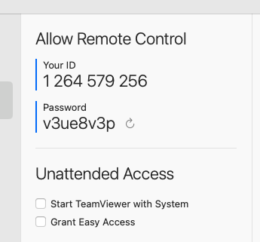
- Email these two numbers to free-e-target.com
- Connect the target to the PC using a USB cable
- Launch the PC Client
When connected you will see changes made to the PC Client screen and occasionally searches for software that should be installed on your computer.
If your help is needed, you will see a message box appear with instructions or questions.

